Hello,
I have problem in programming with p89lpc936. The internal RC oscillator type of programs are programmed well, and working properly. But when I choose the external oscillator, problem occurs. In this manner I have lost 14 IC’s. Please help to rectify my problem.
In flash magic software default config status is RC osc. When I choose external high freq osc, and enable reset pin, and click reprogram. After clicking reprogram, ic is not working and also not programmed. I can’t change config also. The error message is display like this,
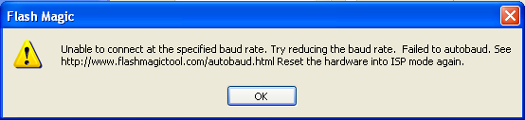
This message is display for all other functions (erase, read sig, read config, write program). My advance option settings given below,
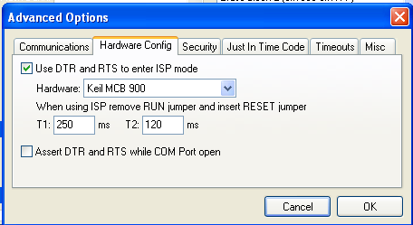
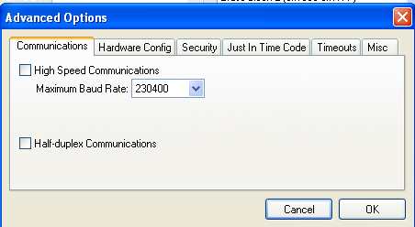

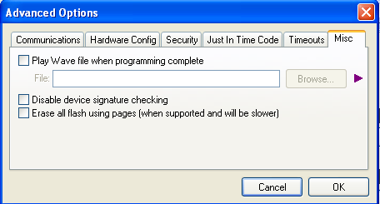
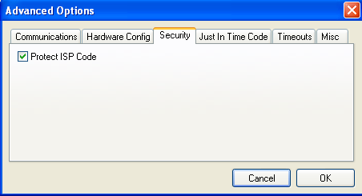

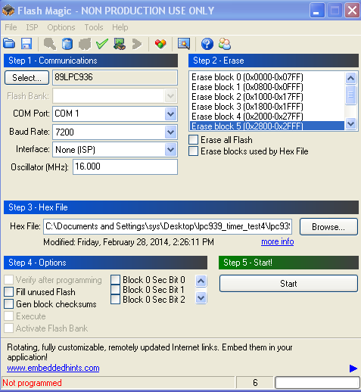
Note :
I have attached 16MHZ crystal. Is it right?
The RC oscillator based programs are working properly.
Already discussed this topic, but I can’t understand with that.
- Please explain how to connect external oscillator with p89lpc936.

